FIR №► | KTI-FIR-RFI-P12567A-TSV-NIR-015 (235651) Rev A | FIR Rev. №► | 0
VISIT DATE/PERIOD► | 05.06.2026
RFI (NOI) №► | RFI-P12567A-TSV-NIR-015 (235651) | RFI (NOI) Rev. №► | Rev A
ITP №► | P12567A-12-99-97-3136 | ITP Rev. №► | Rev. C
ITP ACTIVIY №► | ITP SL. NO. 2.2 - Stamp transfer on rod. | ITP APPROVED DATE► | --
PROJECT NAME► | ADNOC ONSHORE ONE TIE-IN PROGRAM | PROJECT №► | P12567A
CLIENT (EPC) NAME► | M/s. GALFAR | END USER NAME► | M/s. ADNOC Onshore Agreement No.: 4700024655
VENDOR NAME► | M/s. NIRMAL INDUSTRIAL CONTROLS PVT LTD | SUBVENDOR NAME► | -
INSPECTION  LOCATION ► | KPS Forge ( India) Pvt. Ltd. ( Foundry Po. No. 260400704 )Khasra No. 680, Village Duriyai, Tehsil - Dadri, G.B Nagar, Uttar Pradesh, Pin Code 203207, India | COUNTRY► | India

KTI JOB №► | -- |  | KTI Inspector Name► | Mr. Shiv Kumar Singh
CLIENTVENDOR PO/WO №► |  | PO/WO № DATE► |  | --

INSPECTION STEP |  |  | INSPECTION discipline
Pre-Inspection► |  |  | Civil► |  |  | Mechanical► |  |  | Structural►
Progressive► |  |  | Electrical► |  |  | Welding► |  |  | Coating►
Final► |  |  | Instruments► |  |  | Piping/Pipeline► |  |  | Others►
Stock Materials► |  |  | Telecom► |  |  | Painting►

INSPECTION ATTENDEES
NAME | POSITION | COMPANY | SHOWEN DATE
Mr. Shiv Kumar Singh | KTI Middle East Inspector | OBO (Galfar) | 05/06/2026
Mr. Sailesh | Inspector | OBO (ADNOC) | 05/06/2026
3.2 Inspector not available during visit |  |  | 05/06/2026

DETAILS OF INSPECTED ITEMS THIS VISIT
PO/WO Item №/Sr.no | Quantity | Description | Item Unique Identification
01 | 12 | Round Rod size 75mm Dia x 126 LG (SA) APS A182 Gr. F55 | Batch NO: E428A  HEAT NO: 574699
02 | 01 | Round Rod size 22 mm Dia x 400 LG (SA) APS A182 Gr. F55 | Batch NO: E428A  HEAT NO: 574699

INSPECTION SUMMARY THIS VISIT
- ITP CL NO.: 2.2 - Test Piece Marking for testing Chemical Analysis, Mechanical, Hardness, Impact test, Corrosion, Microstructural and Ferrite content Test - Stamp Transfer for item no 1 & 2 Qty 12 Nos and 01 No. for future testing Heat no. 574699 batch No E428A and identification marked as “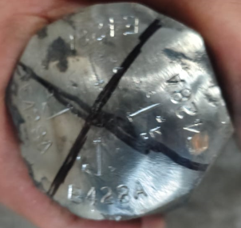”.
- Heat Treatment Chart- Reviewed heat treatment chart and found in order as per standard.

MAJOR CONCERNS / FINDINGS THIS VISIT
NA

DIGITAL PHOTOS this visit

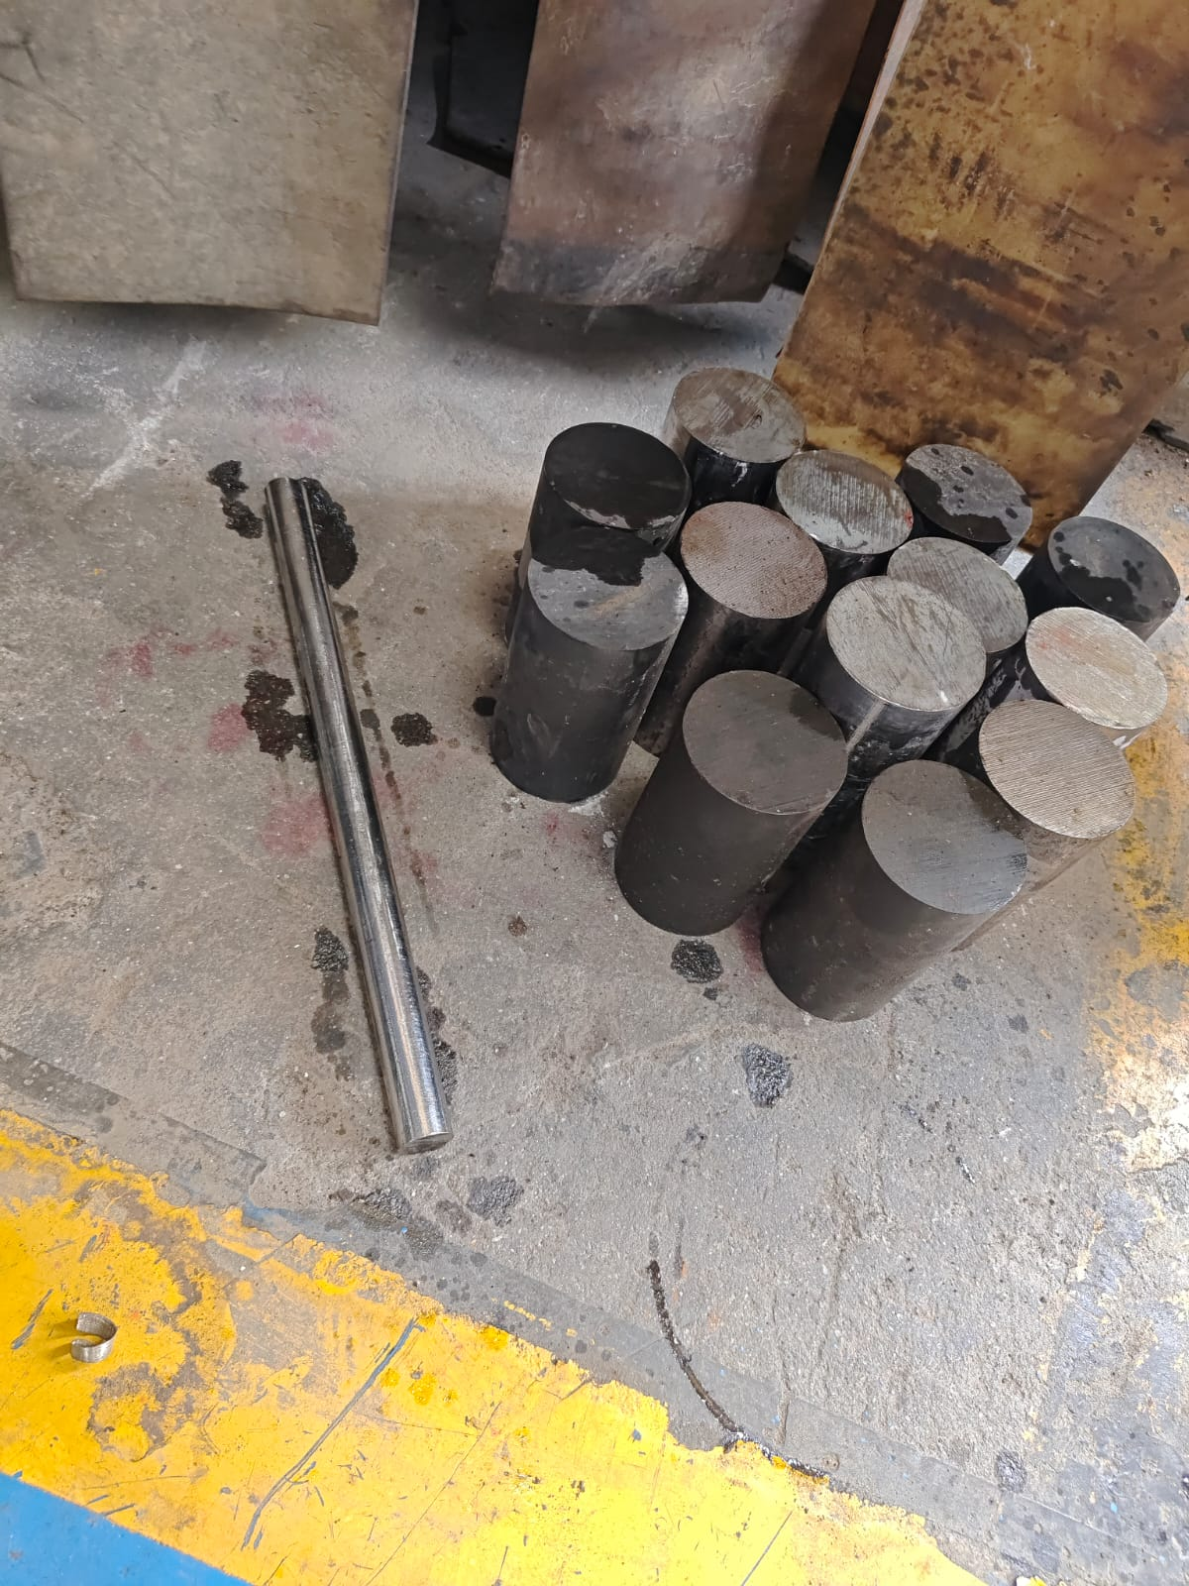 | 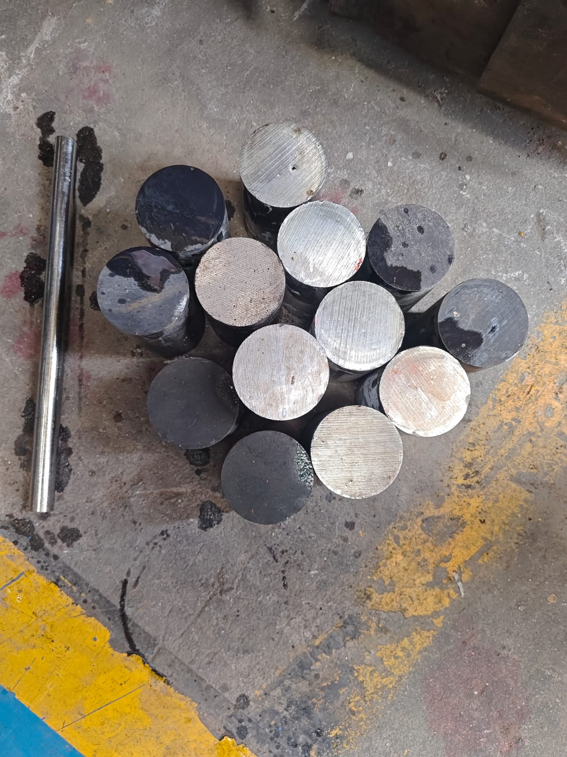
Witness TPM | Witness TPM
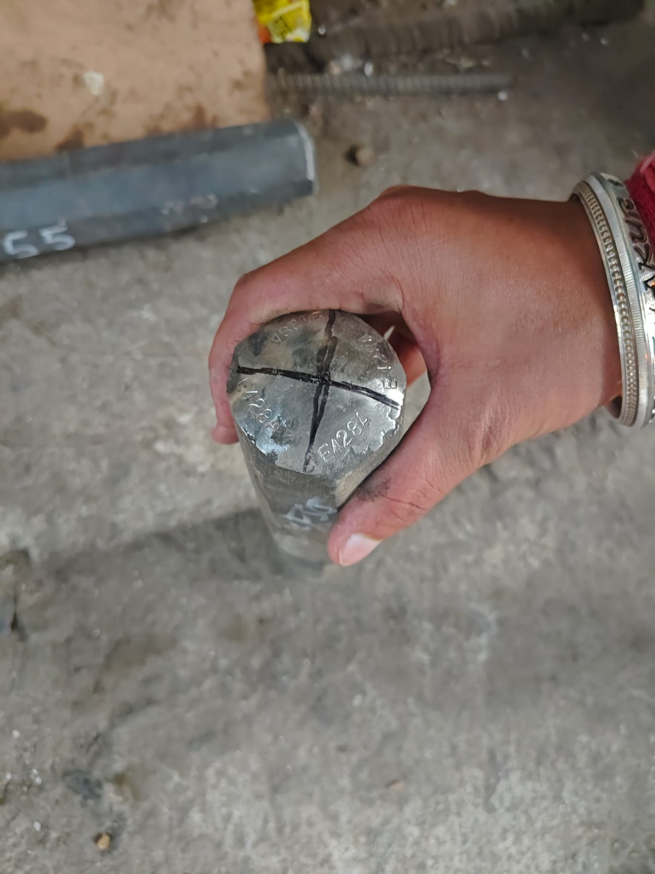 | 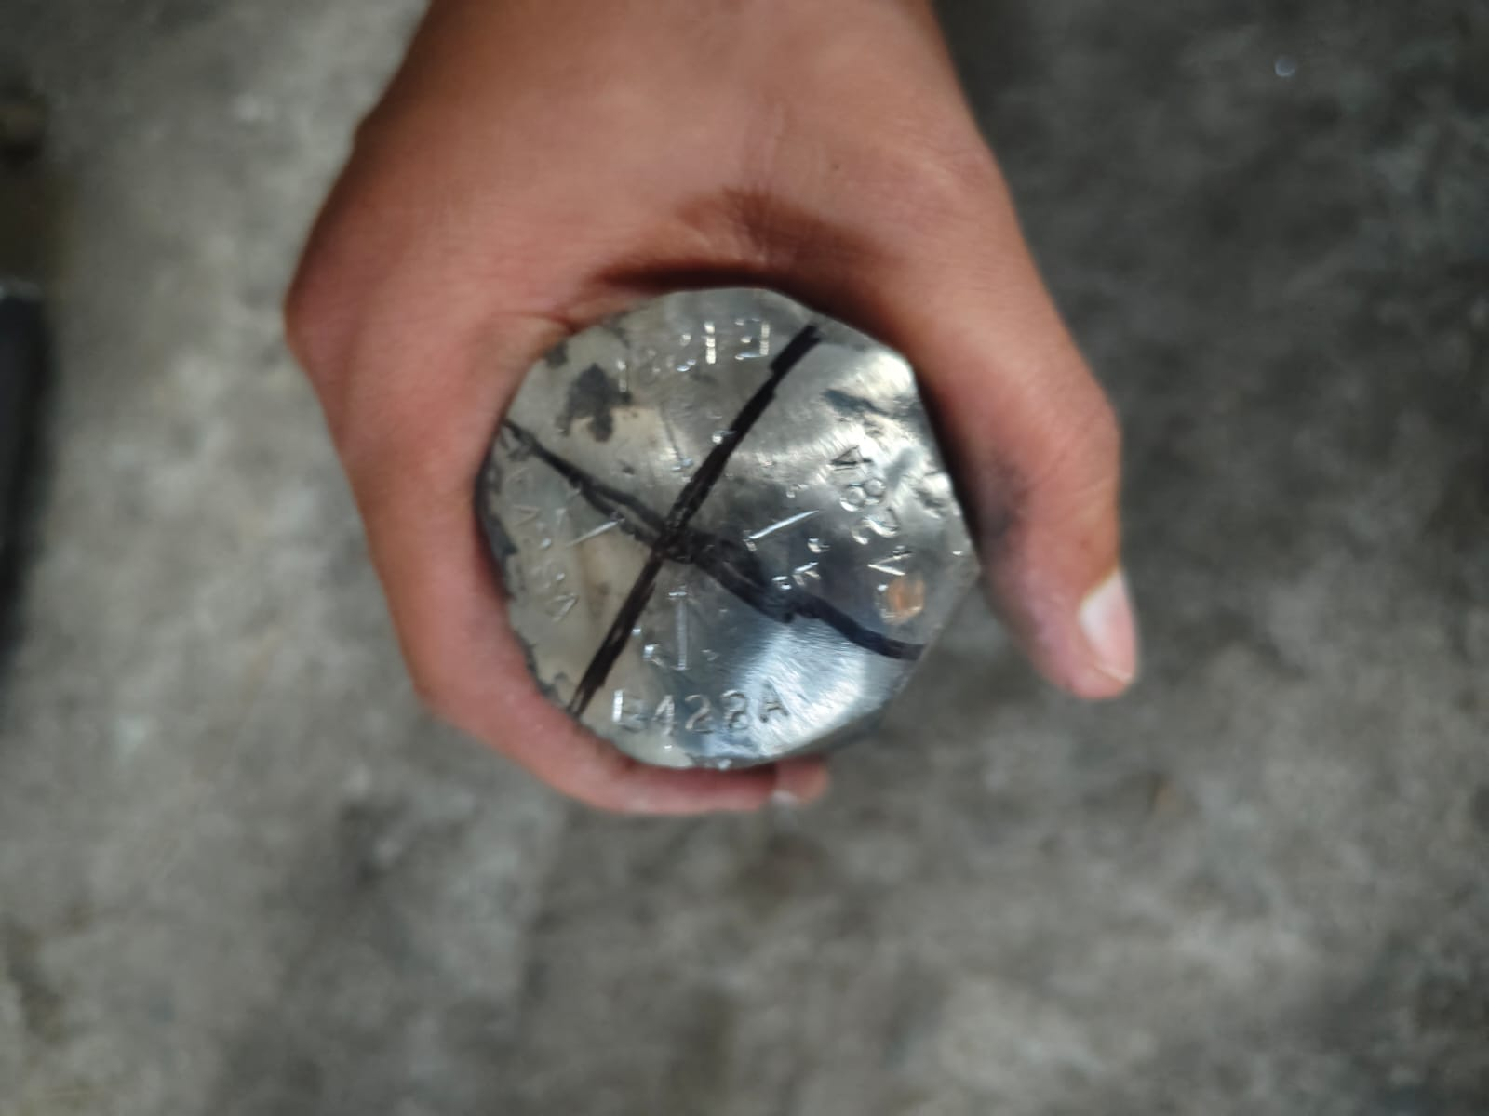
Witness TPM | Witness TPM

Inspection results`THIS VISIT |  |  |  | KTI Middle East Inspector
ACCEPTABLE/SATISFACTORY► | Yes | No |  | Name | SHIV KUMAR SINGH
ACCEPTABLE WITH COMMENTS► | Yes | No |  | Signature | 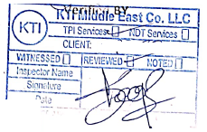
REJECTED► | Yes | No |  | Date | 05/06/2026

++++END OF THE REPORT++++

